# Performance

### Preface

This section of the Operator Manual is for background information only. The Performance section does not contain essential information for the user to make full use of NavVision®.

### Modules

Under “F11 > Modules” the time period is shown that each NavVision® module uses in relation to the total NavVision® time.

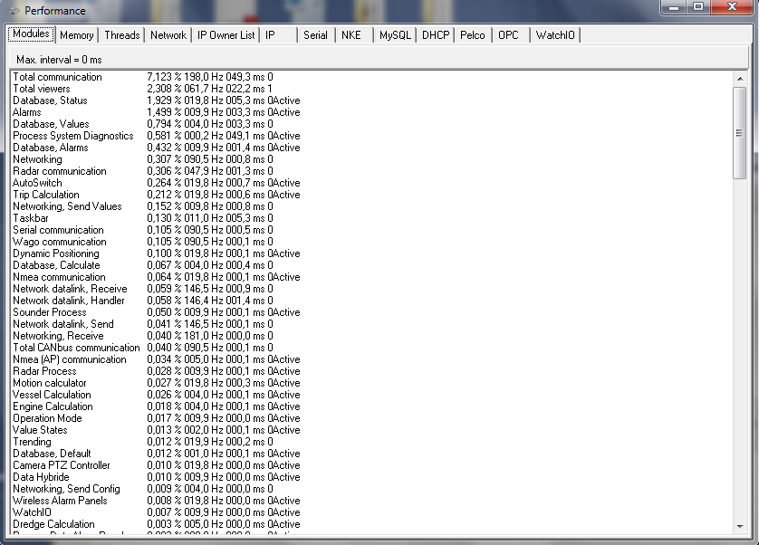

Figure 3‑1: Performance

The columns are arranged as follows:

|  |  |
| --- | --- |
| **Detail** | **Description** |
| Module Name | Internal name used by NavVision® to describe the module |
| Percentage | Percentage of processing time, where total NavVision® is 100% |
| Refresh Rate | Processing time in milliseconds |
| Total time | Total (module) processing time (in milliseconds) |
| Semaphore | Should be “0” or “1” |
| Active | Shows during refresh of screen |

### Memory

Under “F11 > Memory” developers can track for the presence of possible memory leaks.

By default the option “Activate memory manager” is disabled to avoid significant performance degradation.

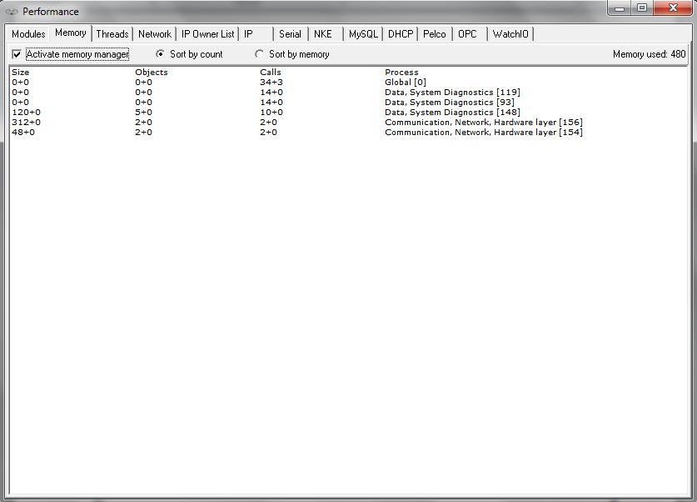

Figure 3‑2: Memory

The columns are arranged as follows:

|  |  |
| --- | --- |
| **Detail** | **Description** |
| Size | The size (bytes) of an object |
| Objects | Relative numberof objects created or deleted since activation of memory manager |
| Calls | Number of creation / deletion calls |
| Process | Process creating / deleting the objects |

 Take special notice of the “Memory Used” at the right top of the pane. If it keeps rising beyond your memory available, a memory leak is imminent.

### 

### Threads

Under “F11>Threads” all the threads that are currently running will be visible. This option is quite easy for troubleshooting certain threads.

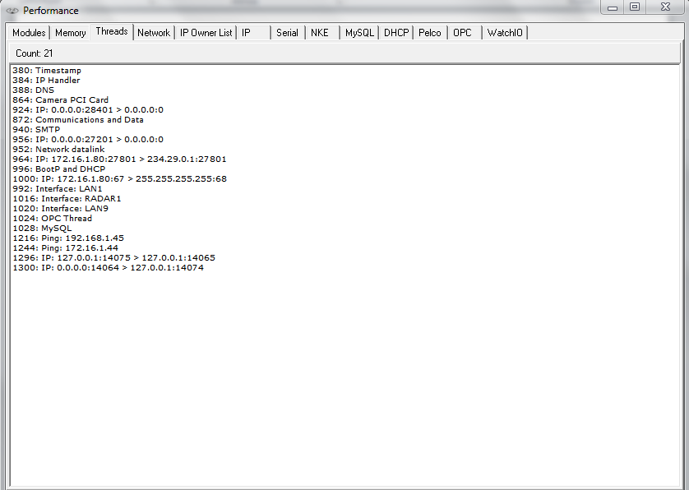

Figure 3‑3: Threads

### Network

Under “F11 > Network” the Connection to other workstations within the same system is shown. With all workstations connected and running, you will see your complete topology visible here.

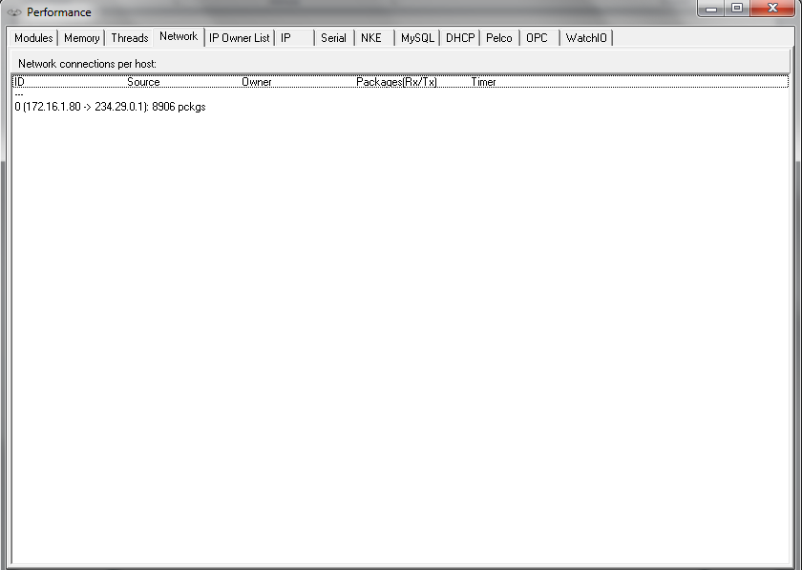

Figure 3‑4: Network

The columns are arranged as follows:

|  |  |
| --- | --- |
| **Detail** | **Description** |
| ID | Internal index used by NavVision®, not of importance in this list |
| Source | Active > when connected  Connect > when trying to connect  Closing > when closing the connection |
| Owner | UDP server, UDP client, TCP server or TCP client |
| Packages | The source of the connection. When “0.0.0.0:0” is shown, no source address was specified when opening the connection, where “0.0.0.0:x” means that port “x” on this computer is being used for server functionality |
| Timer | The destination of the connection |

### IP Owner List (which OWS is handling which ip’s)

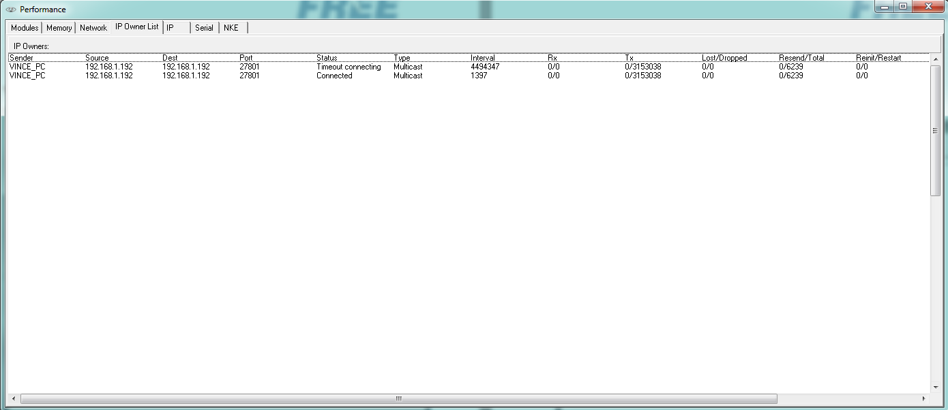

Figure 3‑5: IP Owners List

The columns are arranged as follows:

|  |  |
| --- | --- |
| **Detail** | **Description** |
| Sender | The workstation you are working on |
| Source | The workstation the connection is made from |
| Dest. | The interface that the source is (trying) to reach |
| Port | The port that is used for the connection |
| Status | The status of the connection |
| Type | Type of connection: Multicast, TCP, UDP |
| Interval | The interval between the last attempt |
| Rx | Receiving side |
| Tx | Transmitting side |
| Lost/Dropped | Packages lost/dropped |
| Resend/Total | Packages asked to be resend/total |
| Reinit/Restart | Reinitialisation/restart of the connection |

### IP

Under “F11 > IP” a list of all network connections as handled by the relevant NavVision® workstation is shown

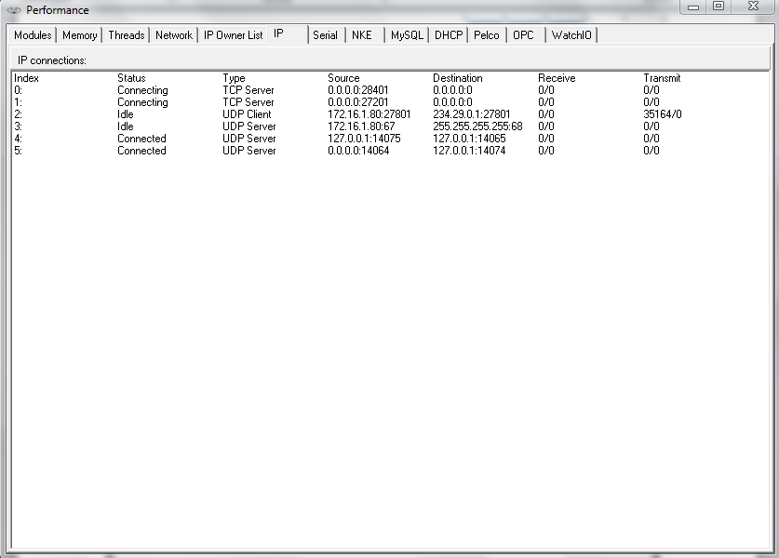

Figure 3‑6: Performance > IP

The columns are arranged as follows:

|  |  |
| --- | --- |
| **Detail** | **Description** |
| Index | Internal index used by NavVision®, not of importance in this list |
| Status | Active > when connected Connect > when trying to connect  Closing > when closing the connection  Idle > When doing nothing |
| Type | UDP server, UDP client, TCP server or TCP client |
| Source | The source of the connection. When “0.0.0.0:0” is shown, no source address was specified when opening the connection, where “0.0.0.0:x” means that port “x” on this computer is being used for server functionality |
| Destination | The destination of the connection |
| Receive | Number of Bytes left in the internal buffer / Number of bytes received |
| Transmit | Number of Bytes left in the internal buffer / Number of bytes sent |

### Serial

Under “F11 > Serial” the serial port status is indicated.

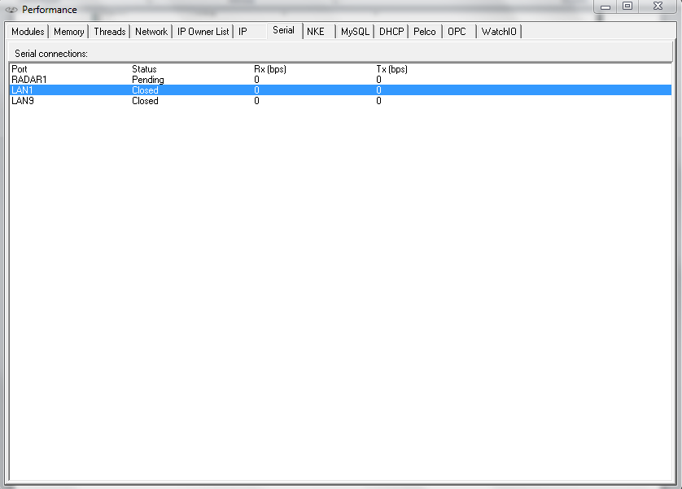

Figure 3‑7: Serial

The columns are arranged as follows:

|  |  |
| --- | --- |
| **Detail** | **Description** |
| Port | The serial port name. The possible radar port is also shown as a serial port, named “RADAR1”. When it is not used, the status stays on “Pending”. |
| Status | Serial port status i.e. “Failed”, “Pending”, “Closed” and “Open” |
| Rx (bps) | Number of bits “Received (Rx)” during the last second |
| Tx (bps) | Number of bits “Sent (Tx)” during the last second. |

For troubleshooting you can right-click on a serial port to see a pop-up you can click for additional data (See Figure 3‑8)

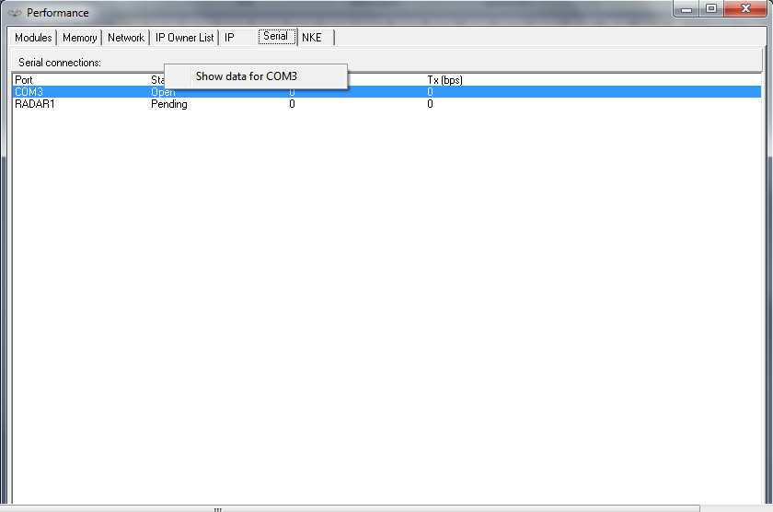

Figure 3‑8: Additional Serial Data

After clicking “show data for x” where x is the appropriate port, you will get a new pop-up field Communication Diagnostics. (see Figure 3‑10 and Figure 3‑10)

This tool you can use to troubleshoot data over serial ports. Here it shows all the data that is actually seen by NavVision® on the specific port.

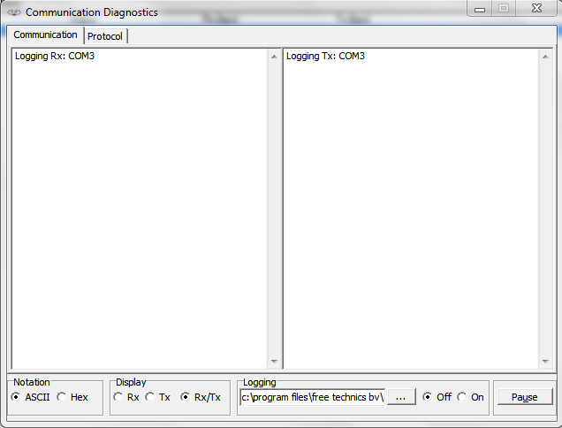

Figure 3‑9: Communication Diagnostics 1

|  |  |
| --- | --- |
| **Detail** | **Description** |
| Notation | Show data in ASCII or Hex |
| Display | Rx > Only show receiving side Tx> Only show transmitting side  Rx/Tx > Show receiving and transmitting side |
| Logging | Choose destination to save logfile and switch it off or on |
| Pause | Pause the data stream |

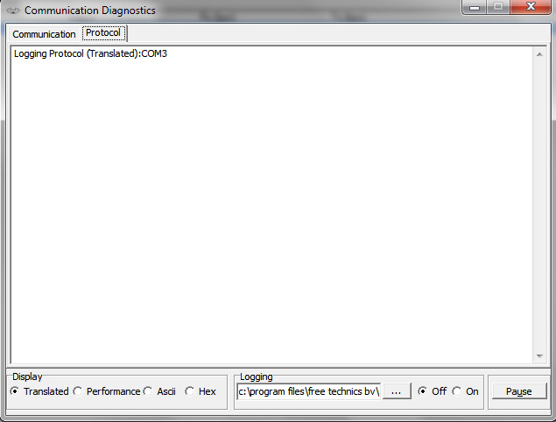

Figure 3‑10: Communication Diagnostics 2

|  |  |
| --- | --- |
| **Detail** | **Description** |
| Protocol | Shows the different protocols |
| Display | Translated > shows the data in readable output Performance > Shows the performance of the data  ASCII > Shows Data in ASCII  Hex > Shows Data in Hex |
| Logging | Choose destination to save logfile and switch it off or on |
| Pause | Pause the data stream |

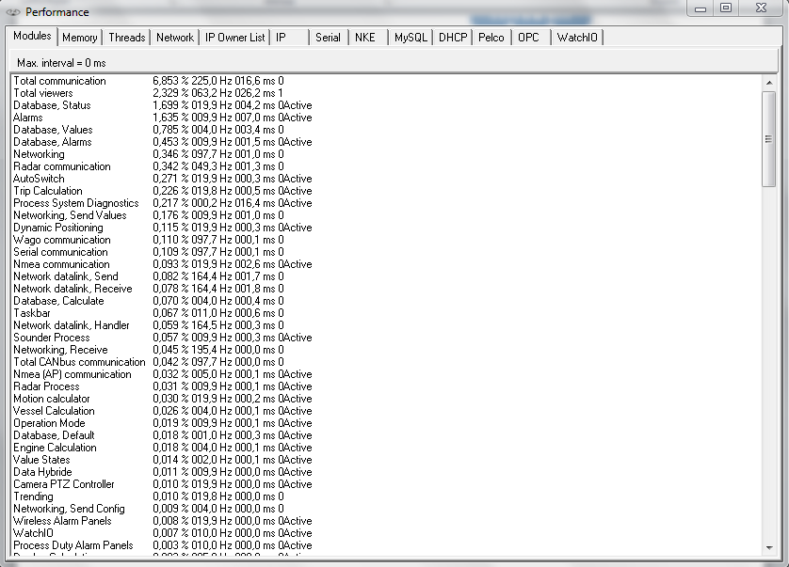

Figure 3‑11: Latest version

In the latest version there are a few new items added. These are however beyond the scope of this manual. Please feel free to explore them